Department of INFORMATION TECHNOLOGY

**ROBUST SECURITY CAMERA**

**SRS**

**Supervisor: SIR SIKANDAR KHAN**

Group members

|  |  |
| --- | --- |
| **NAME** | **CMS ID** |
| SAHAR BATOOL | 41598 |
| HASNAIN RAZA | 41018 |
| HUSSNA ALI | 44072 |
| AFTAB HUSSAIN | 41699 |

**Table of Contents**

**1.** **INTRODUCTION** 3

**1.1** **PURPOSE** 3

**1.2** **SCOPE** 4

**1.3** **DEFINITIONS, ACRONYMS & ABBREVIATIONS** 4

**2** **OVERALL DESCRIPTION** 4

**2.1** **PRODUCT PERSPECTIVE** 4

**2.2** **SOFTWARE REQUIREMENT** 4

**2.3** **HARDWARE REQUIREMENT** 4

**2.4** **REQUIREMENTS** 5

**2.4.1** **FUNCTIONAL REQUIREMENTS** 5

**2.4.2** **NON-FUNCTIONAL REQUIREMENT:** 5

**2.5** **USER CHARACTERISTICS** 6

**2.6** **CONSTRAINTS** 6

**2.7** **DIAGRAMS** 7

**2.7.1** **FLOW DIAGRAM** 7

**2.7.2** **USE CASE DIAGRAM** 8

**2.7.3** **ER DIAGRAM** 9

**2.7.4** **ACTIVITY DIAGRAM (User Side)** 9

**2.7.5** **ACTIVITY DIAGRAM (Admin Side)** 10

**2.7.6** **ASSUMPTIONS AND DEPENDENCIES:** 11

**List of Figures**

**Figure 1 FLOW DIAGRAM** 7

**Figure 2 USE CASE DIAGRAM** 8

**Figure 3 ER DIAGRAM** 9

**Figure 4 ACTIVITY DIAGRAM (USER)** 10

**Figure 5 ACTIVITY DIAGRAM (ADMIN)** 11

**ROBUST SECURITY CAMERA**

# **INTRODUCTION**

Life is what matters a lot for each and every individual. People in every consequence want to live a secure life so, they always prefer using all those software, devices, autonomous systems or others that provide security among which CCTV (Closed Circuit Television) camera plays an important role.

CCTV is one of the feasible functioning/operating requirements that is to be considered in vast safety and security aspects. CCTV cameras are almost installed in every private and public sectors such as educational institutes malls, hotels, firms, cinema etc. in order to provide security and measures such as alarms, site design and systems etc. which are not enough for fulfilling today’s need as the increase in number of surveillance camera footages is challenge for CCTV operator to monitor, analyze and make a decision about whether a dangerous situation is about to happen or not. Monitoring multiple screens continuously is quite risky for the single CCTV operator for prolonged time.

So, to overcome this the automated surveillance algorithm is being developed. The main objectives of this is to train CCTV camera for detection of the weapon (the most common way to harm/ rob anyone) in the image, counting people along-with proper mask detection (most important regarding current situation i.e. Covid-19, as calculated number of people with proper mask application will enter the mall/firm/hotel etc. helping in proper application of SOPs) and alerting the CCTV operator about it through web application while security guard through android application(automated alert message will be send from web app to android app)which were not being provided by primitive/general CCTV cameras but we will assure you regarding proper provision of above mentioned additional features in our project by integrating algorithm of object detection from field of the computer vision and processing of image through automated surveillance.

## **PURPOSE**

The aim of this project is not only security but business satisfaction too as from detection of weapon and proper application of SOP’S (counting people & entering them and face mask detection) till cost effective integration and deployment of CCTV cameras; with which they won’t need to change their cameras rather bringing changes through integration.

Selecting such a project will save cost regarding time, money and labor work as all you need is to integrate all the features in CCTV camera and not to deploy each and every individual system. So, will not only satisfy customer regarding security but will shape business satisfaction too.

## **SCOPE**

It will be based on reviewing and working on ML Models i.e. weapon detection, counting people and face mask detection) and will be consisting of two applications i.e. web-application (highlighting the screen for CCTV operator along-with generating an automated alert message) and android-application (for alerting the guards).

## **DEFINITIONS, ACRONYMS & ABBREVIATIONS**

|  |  |  |
| --- | --- | --- |
| **S.no** | **Acronyms/Abbreviations** | **Definitions** |
| 1 | PYTHON | a high-level programming language used for interpretation |
| 2 | HTML | Hyper Text Markup Language |
| 3 | CSS | Cascading Style Sheet |
| 4 | SQL | Structured Query Language |
| 5 | DFD | Data Flow Diagram |
| 6 | ER | Entity Relationship |
| 7 | IDE | Integrated Development Environment |
| 8 | SRS | Software Requirement Specification |

# **OVERALL DESCRIPTION**

## **PRODUCT PERSPECTIVE**

The proposed system will do real-time weapon detection along-with alertness message if weapon detected, mask detection and count people.

## **SOFTWARE REQUIREMENT**

* Front End:
* Dreamweaver
* Android Studio
* Back End:
* Server
* PHP

## **HARDWARE REQUIREMENT**

* CCTV
* Laptop
* 8 GB RAM
* Intel i5 (3rd generation)
* Nividia GTX (1050) with 4 GB RAM GPU

## **REQUIREMENTS**

### **FUNCTIONAL REQUIREMENTS**

* WEB
* Login
* Input: Enter the provided email and password
* Output: Admin will be able to use the system
* People Counting
* Total no. of entered people
* Current no. of people
* SOP’s Followed
* With mask
* Without mask
* Weapon
* Automatic detection
* Message generation
* **MOBILE**
* Registration
* Login
* Input: Enter the provided email and password
* Output: User will be able to use the system
* Alertness message

### **NON-FUNCTIONAL REQUIREMENT:**

* **USABILITY REQUIREMENT:**

The system must allow the users/admin to access the system via mobile app/web app as mobile app and web app is used by everyone so no need of training.

* **AVAILABILITY REQUIREMENT:**

The system needs to be available and operational 24 hours a day and 7 days a week thus 365 days.

* **EFFICIENCY REQUIREMENT:**

The system must work as efficient as it is proposed to do.

* **ACCURACY:**

As our system is based on real-time detection so it is required to provide 100% accuracy.

* **PERFORMANCE REQUIREMENT:**

The system must generate and send message within milliseconds if an object gets detected.

* **RELIABILITY REQUIREMENT:**

As our system is based on security so it contains sensitive data thus requires maximum reliability due to the importance of data and the damages that can be caused by incorrect/incomplete data.

## **USER CHARACTERISTICS**

* User Module
* Registration
* Login
* Message Receiver
* Administration
* Login
* Monitoring
* Message Generator

## **CONSTRAINTS**

The system should generate and send alert message as soon as possible and the user(s) should be notified too.

## **DIAGRAMS**

### **FLOW DIAGRAM**

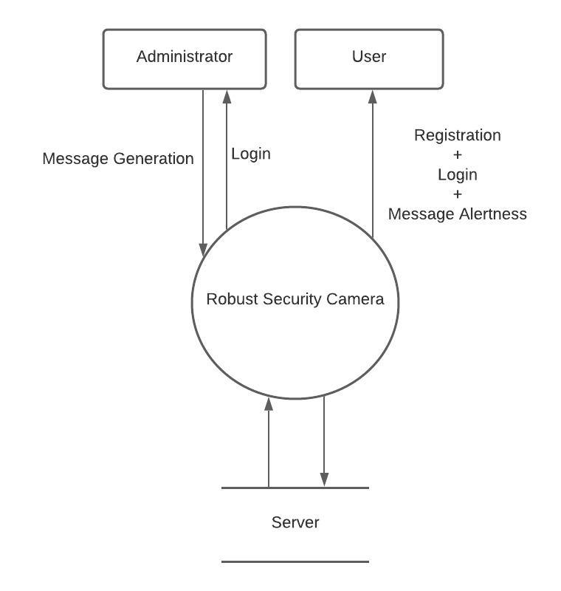

**Figure 1 FLOW DIAGRAM**

### **USE CASE DIAGRAM**

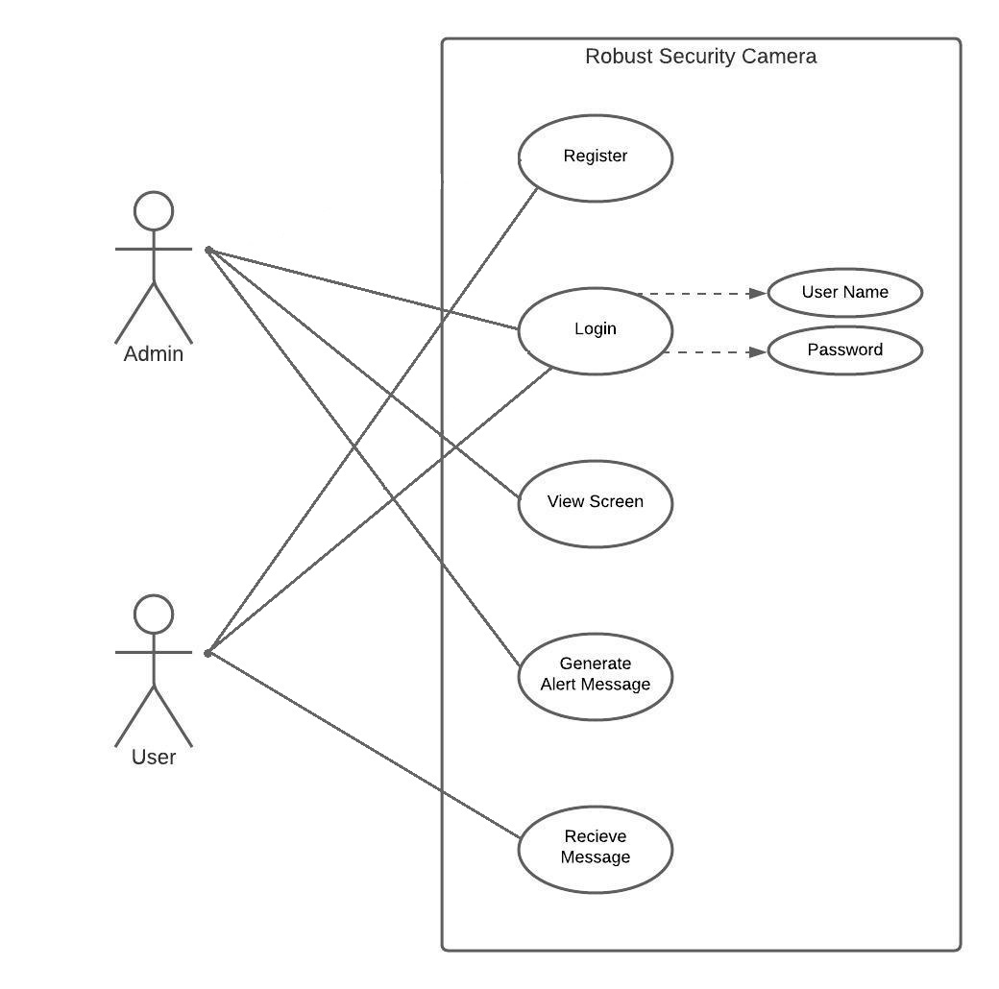

**Figure 2 USE CASE DIAGRAM**

### **ER DIAGRAM**

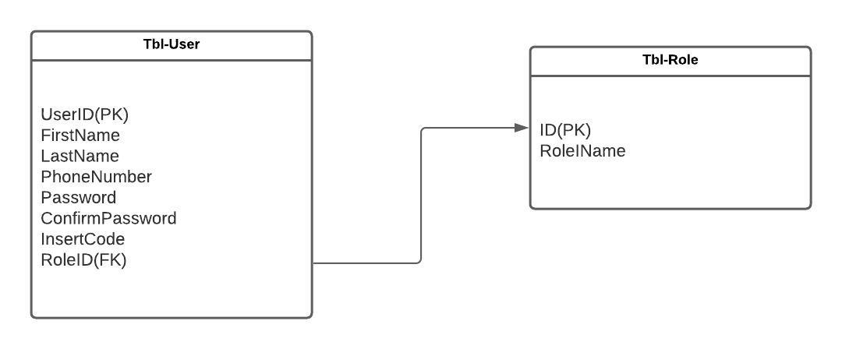

**Figure 3 ER DIAGRAM**

### **ACTIVITY DIAGRAM (User Side)**

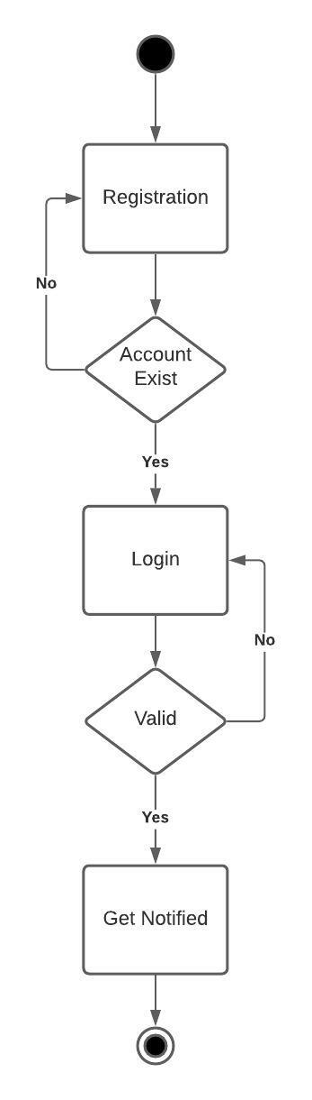

**Figure 4 ACTIVITY DIAGRAM (USER)**

### **ACTIVITY DIAGRAM (Admin)**

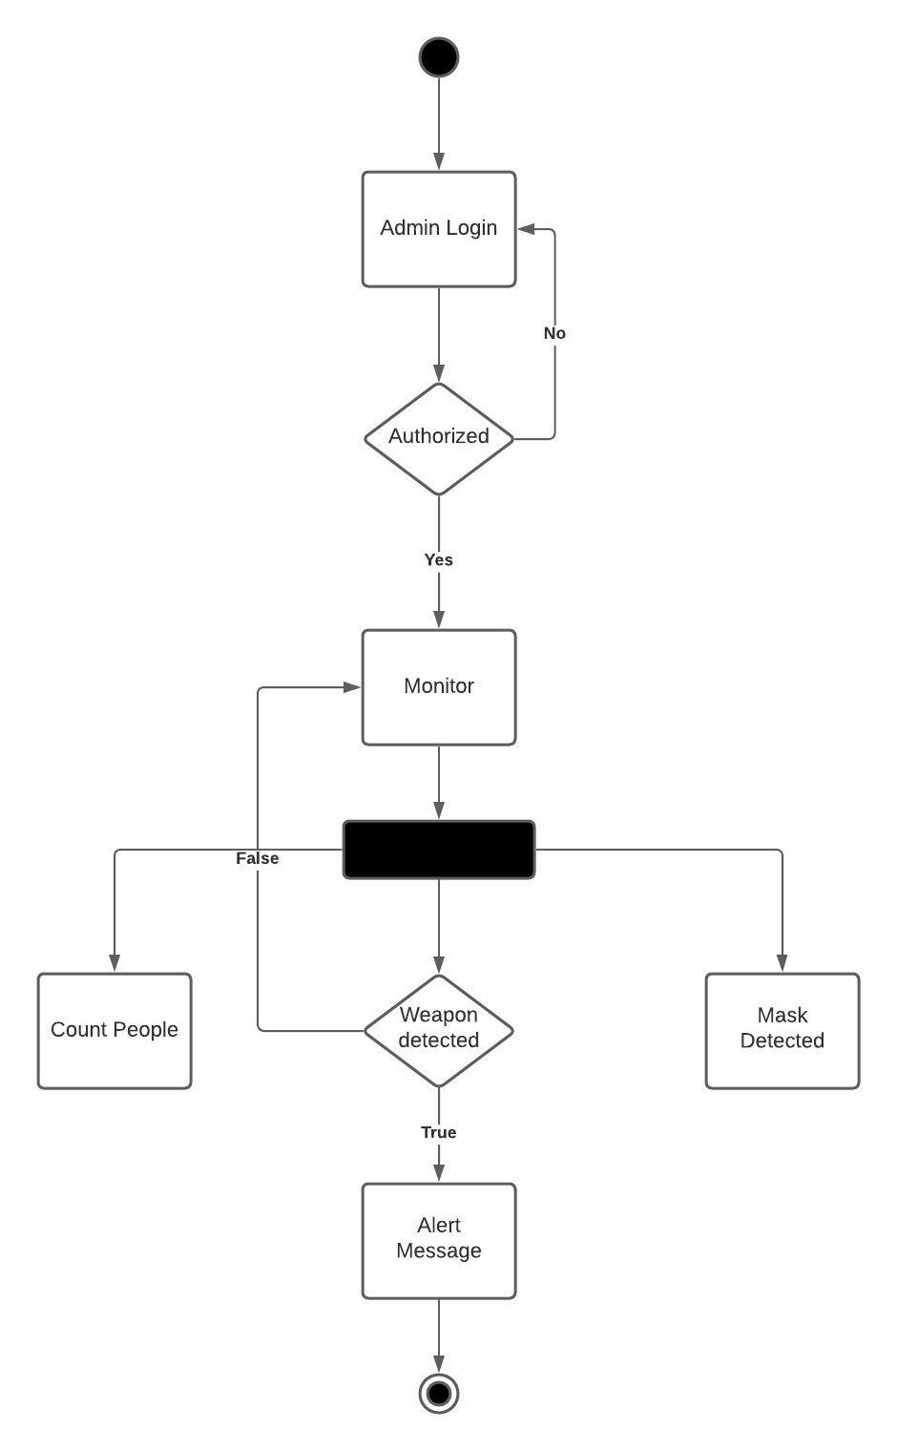

**Figure 5 ACTIVITY DIAGRAM (ADMIN)**

### **SEQUENCE DIAGRAM**

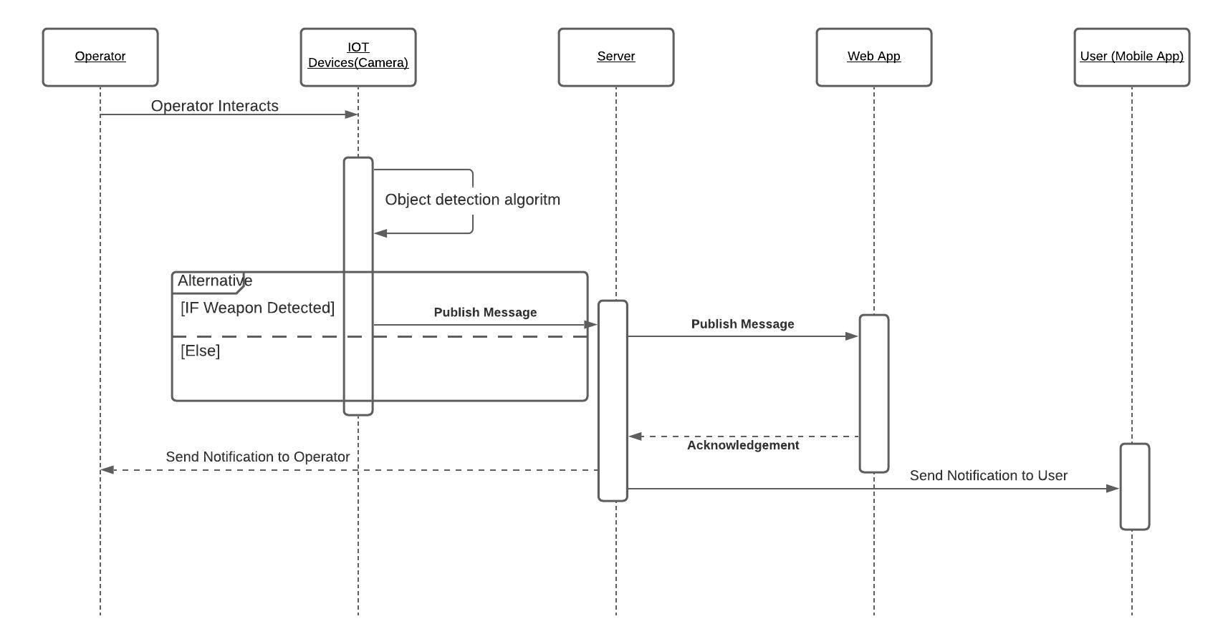

## **ASSUMPTIONS AND DEPENDENCIES:**

Our project needs following applications for the implementation of project:

* Anaconda (for development and running ML (machine learning) models)
* Dreamweaver (for development of web page interface)
* Android Studio (for development of mobile application interface)